ACFID LOCALLY-LED ACTION TOOLKIT

A guide for Australian NGOs
Contents
ABOUT THIS TOOLKIT 2
FOR FACILITATORS - GUIDANCE FOR SAFE USAGE OF THIS LOCALLY LED ACTION TOOLKIT 4
UNDERSTANDING LOCALLY-LED ACTION 8
USING THIS TOOLKIT 11
LOCALLY-LED ACTION CONTINUUM 15
DOMAINS 17
TOOL 1: PARTNER AND STAKEHOLDER MAPPING 18
TOOL 2: REFLECTION ON CURRENT PRACTICE 21
TOOL 3: SELF-ASSESSMENT OF CURRENT PRACTICE 23
TOOL 4: ACTION PLANNING 25
ANNEXES 29

ABOUT THIS TOOLKIT
This Locally-led Action Toolkit (the Toolkit) has been developed by the Australian Council for International Development (ACFID) to help ACFID members progress their commitment to locally-led action.
The Toolkit is designed to:
- provide practical self-reflection tools to help ACFID members discuss, reflect on and take active steps to progress their organisation’s commitment to locally-led action.
- provide a common framework and language for ACFID members to use when talking about locally-led action.
- help ACFID members meet the requirements in the ACFID Code of Conduct.
- provide additional resources and examples to spark ideas and build understanding.
ACFID recognises that efforts to progress locally-led action will require changes at a systemic, organisational and individual level. The Toolkit is deliberately focused at the organisational level.
ACFID members have a diverse range of operating models, approaches and practices, and there will be a variety of actions taken to progress locally-led action. This Toolkit is a stimulus to help organisations engage in discussions about their current practices and the possibilities for change.
The Toolkit is not designed to:
- compare organisations.
- specify actions that must be taken.
- be used as an assessment tool by ACFID.
The Toolkit is a ‘living’ document, informed and updated by ACFID as priorities emerge through dialogue and research. It will benefit from ongoing collective reflection, iteration and improvement.
The Toolkit will support commitments made by ACFID and its members through Resolution 1-2022 Decolonisation, Anti-Racism and Locally Led Action which aims to advance the sector’s commitment to more equitable and just ways of working, which prioritise local knowledge, expertise, leadership and autonomy.

How was this Toolkit developed?
The development of this Toolkit is the next step in a long-term journey towards more locally-led development and humanitarian action in the Australian sector. It builds on previous research, discussions, ACFID resolutions and global commitments and sits alongside parallel work on anti-racism and decolonisation.
This Toolkit has been informed by other international resources and guides, in particular the ‘Power Awareness Tool’ from Partos and the ‘Locally Led Development Guide’ from Bond UK. A small group of ACFID member organisations piloted the Toolkit in early 2024.
ACFID thanks the following individuals and groups who have contributed to and piloted the current iteration of the toolkit: ACFID Locally Led Action Community of Practice, ADARA, Alinea International, Localisation and Decolonisation Group of the Development Practice Community, Salvation Army International Development, See Beyond Borders, St John of God Outreach Services.

FOR FACILITATORS - GUIDANCE FOR SAFE USAGE OF THIS LOCALLY LED ACTION TOOLKIT
Locally-led development, racial justice, and inclusion can be sensitive topics and challenging to discuss as a group.
Some people who have experienced racism, marginalisation, and/or belong to a minority group may find this content distressing. Harm may be caused by these discussions.
Some people may feel personally challenged by the concepts discussed, and their personal, unintentional role in structural racism, and exclusion.
Sensitivity and/or harm in these types of discussions can include:
- Feelings of exclusion; guilt; implicit in an unequal system
- Microaggressions and othering (conscious and unconscious)
- Dismissal of lived experiences and identities; people, identities, culture and communities are not a monolith
- Feeling uncomfortable as discussions will inherently challenge the status quo and our world views
To support a positive outcome from these discussions, it is important that participants feel safe to be open and share their thoughts and feelings.

What can you do?
Creating safer spaces for these discussions in the workplace require planning and consideration.
Do not begin a conversation until the organisational commitment (and resources) are there to finish it; remember it may take time, and several sessions, to work through this critical content.
Ensure that all staff understand that participation in these workshops and discussions are to support organisational development and humanitarian goals by encouraging self-reflection and personal growth of staff.
Provide opportunities for participants in these sessions (safe) options to step out, take a break, if needed. Consider if it is possible for people to choose not to participate in the session; particularly for staff that identify as First Nations and/or of colour.
Invite participants to genuinely and critically reflect on:
- Privilege and power in relationships
- the differences between marginalisation, belonging to a minority group, lived experience, and identity
- the context of white privilege, and disempowering actions on an individual and collective level
- Power dynamics in different contexts – here in Australia, and/or overseas
- Language and how it can be used to ‘include’, ‘other’, ‘harm’ and/or ‘disempower’
Encourage participants to be mindful that others in the session may be finding discussions difficult or sensitive. Set a clear, group goal for the workshop – is it to learn; reflect; or challenge and be contentious?
It is equally important to consider and refrain from culturally unsafe practices and interactions and, where safe to do so, actively challenge potentially unsafe practices and interactions, including such things as stereotyping, discrimination, and racist, sexist, homophobic, transphobic or other demeaning and harmful commentary. Be mindful that some participants (our colleagues and team members) in the room may have experienced one or many of these ‘–isms'.
Remember that language is not neutral; decide on language and actions that will be acceptable, and what will not be acceptable. Actively plan for how to decisively attend to participants causing harm (intentional or otherwise) to others.

Creating brave spaces
These discussions will challenge the ‘status quo’. As such, some participants may feel the need to challenge, be contentious, and/or ask ‘controversial’ questions as part of their journey. While such attitudes do not belong in a safe, learning space - there is an opportunity to create ‘brave spaces’ where participants may channel ‘controversial’ questions.
‘Brave spaces’ can be created by willing allies and/or a skilled facilitator. Colleagues of colour, or those that have experienced racism, marginalisation, and /or belong to a minority group, do not need to be a part of these discussions.
A ‘brave space’ contains five elements:
- “Controversy with civility,” where varying opinions are accepted
- “Owning intentions and impacts,” in which participants acknowledge and discuss instances where a dialogue has affected the emotional well-being of another person
- “Challenge by choice,” where participants have an option to step in and out of challenging conversations
- “Respect,” where participants show respect for one another’s basic personhood
- “No attacks,” where participants agree not to intentionally inflict harm on each other
Creating change can be daunting. See these tools and accompanying discussions as opportunities to work together as a team, an organisation, as a community to find solutions for a more equitable distribution of power, agency, and benefits between all.
We recommend that you also give a reminder about your organisation’s EAP in conjunction with this guidance.

UNDERSTANDING LOCALLY-LED ACTION

Background
The international development and humanitarian sector is inherently shaped by politics and power. ACFID members recognise their shared responsibility to establish equitable partnerships, and to contribute to a more just system where local actors are resourced, supported and trusted, to lead and respond to the needs of their communities.
The movement towards locally-led action – reflected in global commitments such as the Grand Bargain, the Charter for Change and Pledge for Change – is important to redress historic and ongoing imbalances in power and resources between local and international actors, including both donors and international NGOs.
Working in a locally-led way means transferring power and ownership of development activities and outcomes to local actors who are best placed to understand and make decisions about the needs of their communities. It is inextricably linked to the concept and practice of anti-racism.
Research commissioned by ACFID in 2022 showed that ACFID member organisations hold diverse objectives for engaging in locally led action. The most common objectives focus on:
- Improving the effectiveness, relevance and sustainability of development and humanitarian action through recognising the intrinsic value of local knowledge, networks and cultural understanding in the design and delivery of programs.
- Nurturing strengths-based partnerships to build local capacity for development and humanitarian action.
- Redressing historic and ongoing imbalances in power and resources within the development and humanitarian architecture, particularly between local and international organisations.
Visit the online Locally-Led Action Resource Hub to explore the concept and practice of locally-led action further.

Defining Locally-Led Action
There are a wide variety of definitions of ‘locally-led action’ and related terms including ‘localisation’ and ‘local actors’. The term localisation is often used to refer to the process by which development and humanitarian initiatives become more locally-led.
Following consultation, the following definitions have been adopted in the ACFID Code of Conduct:
Locally-led development and humanitarian action | Locally-led development and humanitarian action recognises, respects and strengthens the leadership and decision-making of local actors who are best placed to understand and respond to the needs of their communities. By its nature, this will look different in each country context, and even within countries or programs. Successful locally-led action recognises how power imbalances influence development and humanitarian initiatives. It is facilitated by strong and equal partnership, quality direct funding, transparency and mutual accountability, and diversity and empowerment in staffing and leadership.
Local actors | A wide range of individuals, organisations and institutions, who have the knowledge and expertise to understand and respond to the needs of their communities. This can include local and national governments, local and national NGOs, civil society organisations, community-led organisations and communities.
Anti-racism | Anti-racism refers to the everyday deliberate actions that aim to eradicate the racism that exists at interpersonal and systemic levels. It means actively standing up to and challenging racism.

ACFID Code of Conduct
As signatories to the ACFID Code of Conduct, ACFID members have made a commitment to:
- seek to reduce power imbalances and invest in locally-led development and humanitarian initiatives.
- invest in the sustainability and effectiveness of their collaborations and partnerships.
To demonstrate their commitment, ACFID members are required to:
- have an organisational commitment to locally-led action, which is evidenced by a policy, statement or guidance document.
- name and address power imbalances in organisational relationships relevant to the member’s development and humanitarian initiatives.​
- ensure the voice and decision-making of local actors is evident in:
  - all stages of a program
  - the allocation of resources
  - the design and evaluation of feedback and complaints mechanisms.
- listen to and respond to the priorities of their local partners around organisational strengthening.
ACFID members also commit to actions which promote locally-led action in other areas, including managing risk with partners, their research approaches and communication materials. Download the full list of ACFID Code of Conduct requirements related to locally-led action.

USING THIS TOOLKIT

Who should use this Toolkit?
This Toolkit is designed to help Australian NGOs reflect on current decision-making practices and the distribution of power, particularly in their partnerships with local actors, as they move towards becoming more locally-led. The Tools are designed to be used by a wide range of organisations, with diverse operating models and structures.
The Toolkit can be used by anyone within an organisation who is seeking to drive change.

Ways to use the Toolkit
There are multiple ways you can use this Toolkit. Here are some suggestions:
- Bring together a small team representative of different organisational functions, who can participate in discussions using the Tools, and act as champions in their own work areas.
- Use the Tools to support a guided conversation with your Board and/or senior leadership.
- Start small and focus just on one program or project.
- Focus on one or two Domains to get started, and involve individuals from those work areas.
- Revisit the Toolkit on an annual basis to reflect and monitor progress against the action plan.

Engaging with partners
This Toolkit has been designed for ACFID members to use internally. It’s particularly designed for organisations that may be looking to start or extend their understanding, discussions and self-awareness about locally led action. The tools will hopefully inform future steps of engaging with partners and seeking their input and perspectives on being more locally led.
If you are considering using some tools with partner organisations, ensure planning and adaptations have been made to support safe and effective discussions. We remind users that the Toolkit and its facilitation notes do not currently include guidance for this this engagement with partners. However, for ideas on how to have conversations about power with partners, see the Locally Led Action Resource Hub, in particular, Partos’ Power Awareness Tool.

Getting the most from this Toolkit
Here are some general principles to help your organisation get the most from this Toolkit:
- Know your audience: Think about the most effective way to use this Toolkit for your organisation. Consider the background knowledge of participants. Will there need to be preliminary discussions to help build understanding before using the tools? Is there terminology that needs clarifying?
- The power of the collective: These tools are best completed with other people. Different perspectives and experiences from across your organisation will lead to a fuller picture and help identify areas of agreement and disagreement. This may include your Board, as well as staff and volunteers.
- Be open and reflective: Building a safe space where people feel able to express their opinions is essential. Actively welcome differences of opinion and encourage reflection.
- There is no right or wrong answer: These tools aren’t a test, nor are they designed to tell your organisation the ‘right’ action to take. Those participating should be encouraged to ask questions but know that there might not always be a clear answer.
- Be flexible: The tools are there to guide you, not restrict you to one way of doing things. If the questions or approaches aren’t relevant for your organisation, move on or try another section.
- Celebrate strengths: Take the time to appreciate the strengths of your organisation and partners, and your progress so far.
- Be kind: These can be challenging conversations. Consider the wellbeing of yourself and others participating.
- A work in progress: Making change takes time. Think about how your organisation will create the space for ongoing discussions and keep itself accountable.
- Prioritise: Don’t feel like you need to tackle all the tools or all the Domains at once. Be realistic and prioritise as you go.

Overview of the Tools
The Toolkit consists of four tools, designed to be used in sequence.
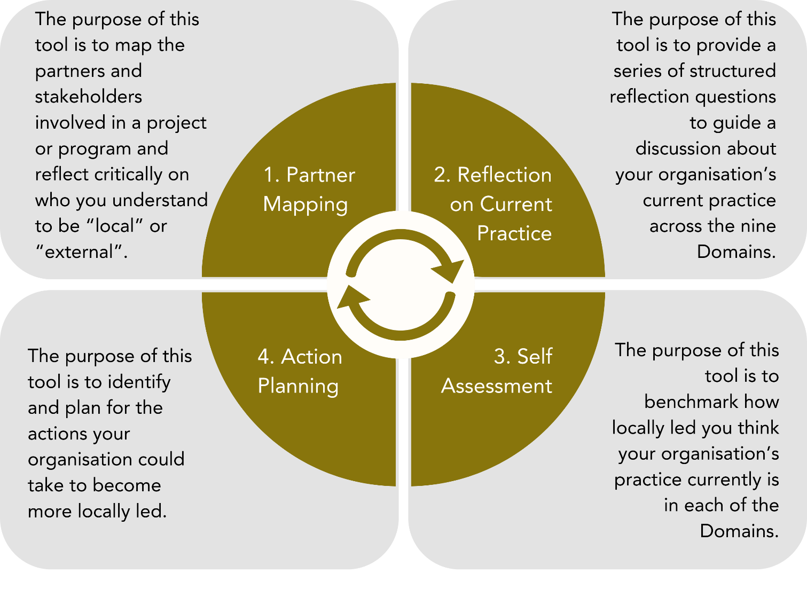

Templates and Spreadsheet
The templates for all the tools are available in the Toolkit’s Annex, and are also available in the Locally Led Action Resource Hub as stand alone word documents that can be edited and printed.
The tools are also available in an Excel Spreadsheet version. This may be useful if you want to transfer the results from each of the tools into one document. It also auto-generates elements such as the Spiderweb Mapping.

LOCALLY-LED ACTION CONTINUUM
The following continuum aims to help your organisation assess and monitor its progression towards more locally-led development and humanitarian initiatives. While it identifies five stages, the continuum should be considered a continuous progression.
The Continuum focuses on who and how decisions are being made. This is closely linked to the concept of power, which can be thought of as ‘the ability to influence the outcomes of decision-making’.
More local/less external
More external/ less local
A. Externally Led, Local Actors Informed | B. Externally Led, Local Actors Consulted | C. Externally Led, Local Actors Involved | D. Locally Co-led with External Delegation. | E. Locally-Led and Externally Supported
Approaches, priorities, decision-making led by External Actors, without systematic engagement with Local Actors. Mostly one-way information flow of key decisions, approaches, priorities to Local Actors. | Approaches, priorities, decision-making led by External Actors, but with systematic consultation of Local Actors which ​​may or may not inform these approaches, priorities and decision making. | Approaches, priorities, decision-making led by External Actors, but with actively sought ​​systematic involvement of Local Actors to inform these approaches, priorities and decision making. | Approaches, priorities and ​​decision making is shared by both Local Actors and External Actors. The delegation of who leads on what is generally delegated by the External Actors. | Approaches, priorities, decision making led by ​​Local Actors, with External Actors providing ​​support where requested or invited by the Local Actors.
There are many areas where decision-making takes place, even within a single project. For example, program design, the allocation of resources, design of monitoring and evaluation plans. This Toolkit refers to these areas as Domains, which are aligned with the Quality Principles in ACFID’s Code of Conduct. Tools 2 and 3 will support your organisation to reflect on where you currently sit on the Continuum, across a variety of Domains.
The Continuum deliberately does not include specific indicators for each stage in the continuum. It is designed to be applicable across a wide at a variety of Domains, operating structures and models, and scales of operation.

DOMAINS
This Toolkit uses nine Domains, which reflect key areas of an organisation’s systems and processes. The Domains provide a structure to help organisations reflect on the different levers and areas in which they can progress their efforts towards locally-led action. The Domains broadly align with other international frameworks and tools, and use terminology aligned to the ACFID Code of Conduct. They are not exclusive, and there may be activities and actions which fall outside or across the Domains which you organisation may wish to discuss.
Visit the online Resource Hub for practice examples from other organisations and additional resources related to each Domain.
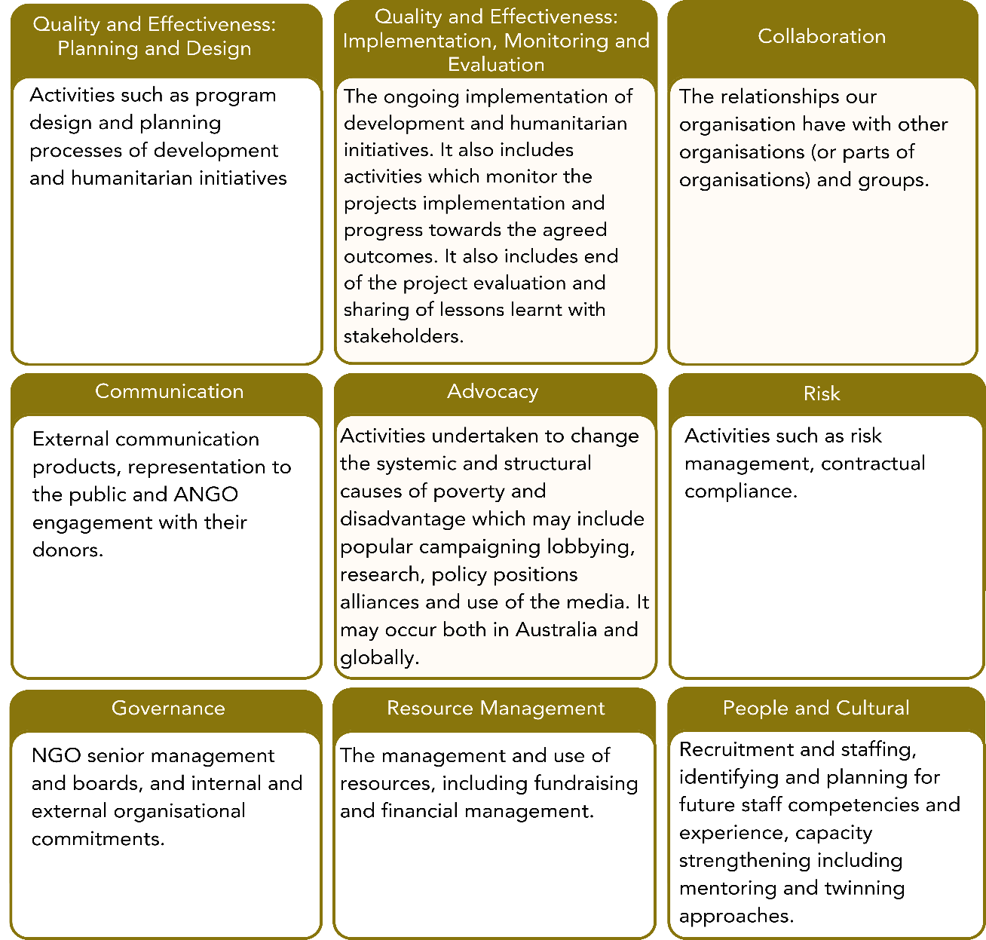

TOOL 1: PARTNER AND STAKEHOLDER MAPPING

Purpose
The purpose of this tool is to map the partners and stakeholders involved in a project or program and reflect critically on who you understand to be “local” or “external”.
- Scene Setting
Depending on the group of people you are using this toolkit with, you may want to start with a stimulus activity, or scene setting exercise. This could include reading or watching a resource from the Locally Led Action Resource Hub and discussing the key messages, how participants feel about the messages, and what they mean for your organisation and work.
- Orientation to the Locally Led Action Continuum
Introduce the Locally Led Action Continuum to the group. You may want to discuss issues such as:
  - The value in moving from a more externally-led approach to a more locally-led approach.
  - What people’s initial thoughts are on who “local actors” and “external actors” are in your operational context.
  - What people’s initial thoughts are on where your organisation’s approach currently sits
Note that to use this Continuum, the group needs to first come to some consensus on who is a local or external actor. This will lead into Tool 1: Partner and Stakeholder Mapping.
- Facilitation Suggestion
As a group, first write each partner/stakeholder on a piece of paper, then move them around on the floor or wall to order them – this may be easier and more conducive to discussion than sitting around a piece of paper.
- Facilitation Suggestion
Each participant could do this as an individual activity first, then come together to compare your maps, and see where the differences are and work towards a consensus position.
Alternatively, you could split the group up and each sub-groups map a particular program and project, then come back together, note and discuss any differences, and work towards consistency across projects.

Instructions
- Determine the program or project you will be mapping.
It could be a group of projects with a similar structure (which would involve listing more general categories of partners and stakeholders), or one specific project/program (which would involve listing specific organisations, offices, groups, etc). Ensure that everyone in the discussion is aware of what you are mapping.
- Identify the program/project’s Primary Stakeholders (i.e. most local stakeholder).
These are the people or groups who are directly affected by and who are impacted by the project’s activities.
- Identify and list the stakeholder(s), that are furthest away from the Primary Stakeholders. (i.e. the most external stakeholder)
This may be your own organisation, or your part of the organisation.
- Identify and list the partners/stakeholders that sit between the two groups identified in Step 2 (most local) and Step 3 (most external) actors.
They will be partners/stakeholders that are engaged, or could potentially be engaged in, decisions about the project. They may be organisations, offices of organisations, groups of people. Add or remove as many rows as necessary to fit your mapping.
- For each of the partners/stakeholders, discuss and decide in your group if you consider them “local” or “external”.
You will refer to these categories later, when you are assessing where your organisation’s practices sit on the Continuum of Locally Led Action.
- Repeat the process for the other programs/projects you would like to be part of your discussions for the rest of the Tools.

To note
- While the mapping template is set up like a ladder or hierarchy, there may be stakeholders and partners that don’t sit in a neat cascading chain of implementation. For the sake of this exercise, don’t worry too much about the order in the middle of the map, this won’t affect future – focus more on if you consider the stakeholder to be local or external.
- This is a subjective exercise, and different people in your organisation may have different opinions, or you may have different opinions in the future of how you label them.
- At this stage, you are not making any determinations about the power dynamics between these partners/stakeholders - this will be reflected on later in Tool 2: Reflections on Current Practice.

TOOL 2: REFLECTION ON CURRENT PRACTICE

Purpose
The purpose of this tool is to provide a series of structured reflection questions to guide a discussion about your organisation’s current practice across the nine Domains. The questions are designed to prompt reflection and debate and should be used as a catalyst for discussion.

Facilitation
- Use with Tool 1: Partner and Stakeholder Mapping
Many of these reflection questions are “Who” questions – it may be useful to have your Partner and Stakeholder Mapping(s) in front of you, and to refer to the partners and stakeholders listed in this tool as you discuss your answers.
- Scope of reflection
In the earlier tool, you may have focused on specific projects and programs. For this tool, you can choose to consider your organisations entire portfolio of projects/programs and partnerships OR it may be more appropriate to consider some programs separately if they have a significantly different partnership approach.
- Question selection
A range of Reflection Questions have been provided – there are probably too many to go through each question for each Domain, and some questions may not be relevant to your context. The facilitator should use the lists like a menu, and chose e.g. 3-5 questions for each Domain.
- Facilitation Suggestion
If time is limited, split the group into sub-groups, and each sub-group discusses 1 or 2 Domains each. They can report back in plenary.
- Facilitation Suggestion
Some organisations may want to involve specific personnel with specific Domains – e.g. Fundraising and Marketing team for the Communications Domain; Management Team and Board with Governance Domain.
Alternatively, your organisation may choose to have a mix of personnel complete all the questions together so they can share and hear each other’s perspectives and have a more wholistic view of the organisation’s current practice

Instructions
- Facilitator reviews the list of questions and decides which ones the group should focus on.
The selection will be informed by the time available, people who will be involved and relevance to your operating context.
- Discuss the Reflection Questions.
Reflect on only one domain at a time. You don’t need to land on an answer for each question, but explore issues around power that you may not have discussed as a group before and reflect on who is leading action and decision making.
- Note any key reflections from each discussion.
These notes will serve as a record for when you complete the next tools, but also if your organisation repeats the Tools in the future. It may be different staff completing it, so a record of the key points of your discussion will help track how practice is changing over time.

TOOL 3: SELF-ASSESSMENT OF CURRENT PRACTICE

Purpose
The purpose of this tool is to benchmark how locally led you think your organisation’s practice currently is in each of the Domains.

Facilitation
- Deciding on a continuum rating
  - The determination of where your organisation is on the Continuum for each domain will likely be a balancing act – there will be some approaches, tools, policies, practices that are more locally led, and some that are more externally led. You will need to look at your current practice overall, and decide, on balance, where you are on the Continuum.
- Importance of noting specifics of your current practice
  - Ensure you note examples of both the more locally led and more externally led factors of your practice for each domain, so in the future, when the organisation looks back on this document there is a clear reminder of what your practice was at this point, and how you made the Continuum determination.
- Subjective nature of the ratings
  - Like Tool 1, this is also a subjective exercise, aimed at promoting discussion and new and critical thinking within your organisation. It’s unlikely that staff participating in the exercise will have the same views on where the organisation are placed on the rating. The Continuum rating could change over time as your organisation changes who they consider a “Local Actor” and “External Actor”. The key outcome of this tool is the critical thinking, developing new viewpoints and the beginning of awareness that there are possibilities for new ways of operating.

Instructions
- Determine where you would place your organisation on the Continuum for each Domain.
To make this determination, you will need to refer back to:
  - The Locally Led Action Continuum for descriptions of the 5 levels of Locally Led Action
  - Tool 1: The Partner and Stakeholder Mapping to which actors you have classified as “Local Actors” and “External Actors”
- Note down the key factors that were part of your consideration.
These could be specific practices, processes, policies, approaches and may be positive (ie drive the organisation to be more locally led) or negative (drive the organisation to be less locally led). By recording these, you will have a record for when you revisit this tool in the future, and know why certain ratings were made.
- Map the results on the Spiderweb Diagram
Put a cross on the Spiderweb for each rating, then join the crosses. This will make it clearer to see which Domains your organisation feels it is more and less locally led in. This can be a point of validation, to check back on any Domains that the group may feel hasn’t been assessed consistently with the others.

TOOL 4: ACTION PLANNING

Tool 4a: Action Identification

PURPOSE
The purpose of this tool is to brainstorm the actions your organisation could take to become more locally led.

FACILITATION
- Stimulus resources
To help generate ideas about what your organisation could do to become more locally led, you may want to spend some time looking through stimulus resources including:
  - ACFID’s Locally Led Action Resource Hub
This has curated resources, including those that suggests actions organisations can take in each of the 9 Domains.
  - Practice Examples
Within the Resource Hub are short practice examples from ACFID members of how they have advanced their locally led action in specific Domains.
- Sphere of Control vs Sphere of Influence
- Sphere of Control
These actions are those that your organisation can make decisions about, and have a significant level of control over.
- Sphere of Influence
These actions are those that an organisation can not directly implement. Some organisations work in networks or federations that they may have certain processes, policies and ways of working – but the organisation can have influence by providing suggestions, lobbying, or starting conversations. Many organisations also work within systems and processes that are larger than themselves (eg DFAT funding requirements) that may limit what is in an organisation’s control to change, but there may be ways these stakeholders can be lobbied or changed over time.
- Blue sky thinking
At this point, include ideas that are not limited by current practices and beliefs. You will analyse the actions later, and decide which ones to action, so don’t limit ideas at this point.
- Suggestion: Sticky Notes
It may work well to write action ideas on sticky notes. This will enable you to easily move them around as a group in the next prioritisation activity.

INSTRUCTIONS
- Chose the next assessment point.
Decide when you would like to reassess your organisation. A suggestion is in 18 months time, as that will allow enough time to implement some action items, however it may be a shorter or longer period.
- Brainstorm actions that would help your organisation be more locally led.
These should be divided into actions that are in your direct sphere of control, and those that are directed at your sphere of influence.
- Forecast where your organisation could be on the Continuum
Estimate, if you were to implement the actions listed, where would you rate yourself at the next assessment point for this Domain.
- Map the potential shift in Locally Led Practice on the Spiderweb diagram
Over the top of the Spiderweb diagram you made in the last step (of your current practice), map where your organisation could potentially be at the next assessment point. This will give you a clearer view of which Domains you could potentially shift more in, and those that there may be less potential change. This will help you prioritise which actions you do take up in the next step, and which domains you will focus your efforts on.

Tool 4b: Action Prioritisation

PURPOSE
The purpose of this tool is to prioritise the actions that your organisation will take in the next period to work towards being more locally-led.

FACILITATION
- Impact vs Effort Matrix
You may wish to map these actions on an Impact vs Effort matrix (see below), this will work well if you have your ideas written on sticky notes from the previous activity. 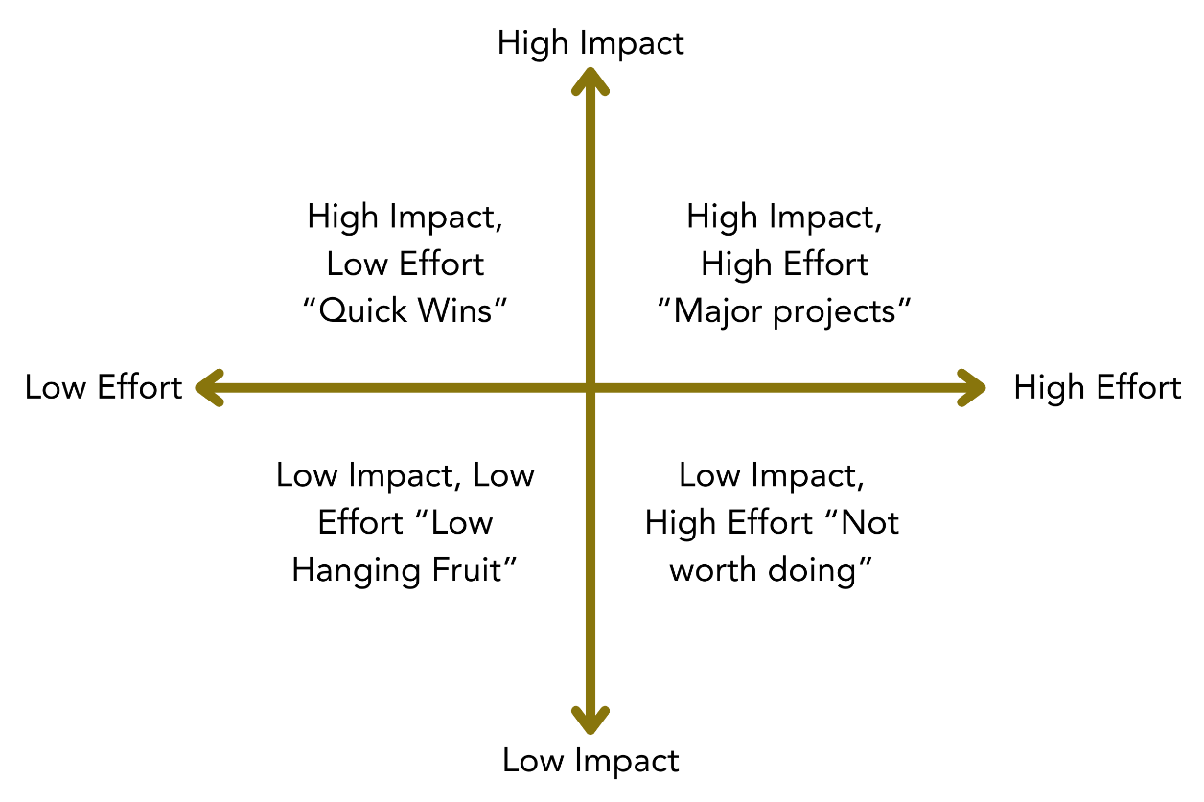

INSTRUCTIONS
- Copy over the actions your identified in Tool 4.a Action Identification
- Effort and Impact Rating
Decide what the level of effort to implement each action would be.
Decide what the impact of each action would be.
- Agree on if the action will be implemented, and if so what priority it is.

Tool 4c: Action Planner

PURPOSE
The purpose of this tool is to establish an Action Planner that will make clear that responsibilities and timeframes for the prioritised actions, and enable the organisation to review progress at the next assessment point.

INSTRUCTIONS
- Transfer the actions that were selected to be actioned into the planner, and complete the additional information required (who will lead, resources required, timeframe).
- Decide how often the organisation will check in to review progress.

ANNEXES

Locally-Led Action Continuum
More locally/ less externally led

More externally/less locally led

A. Externally Led, Local Actors Informed | B. Externally Led, Local Actors Consulted | C. Externally Led, Local Actors Involved | D. Locally Co-led with External Delegation. | E. Locally-Led and Externally Supported
Approaches, priorities, decision-making led by External Actors, without systematic engagement with Local Actors. Mostly one-way information flow of key decisions, approaches, priorities to Local Actors. | Approaches, priorities, decision-making led by External Actors, but with systematic consultation of Local Actors which ​​may or may not inform these approaches, priorities and decision making. | Approaches, priorities, decision-making led by External Actors, but with actively sought ​​systematic involvement of Local Actors to inform these approaches, priorities and decision making. | Approaches, priorities and ​​decision making is shared by both Local Actors and External Actors. The delegation of who leads on what is generally delegated by the External Actors. | Approaches, priorities, decision making led by ​​Local Actors, with External Actors providing ​​support where requested or invited by the Local Actors.

Tool 1: Partner and Stakeholder Mapping - Examples
- 1. Determine the program(s) or project(s) you are mapping: |  | Our project in Cambodia: “Women-Led Empowerment and Food Security in Battambang (WEFIB)”
 |  | Partners and Stakeholders | 5. Do you consider the partner/stakeholder to be an “external actor” or a “local actor”
More external/less local | 3. List the organisation(s) that are furthest away from Primary Stakeholders, in terms of location and representation. | International Development R Us (IDRU the ANGO that is using this tool) | External
More external/less local | 4. List the actors/organisations in between the most external organisation(s) and the most local actors | IDRU International HQ | External
More external/less local |  | IDRU Cambodia National Office | External
More external/less local |  | IDRU Cambodia’s Provincial Office | External
More external/less local |  | District-level local NGO’s sub-contracted to implement the project | Local
More external/less local |  | Women’s groups, OPDs, Village Development Committees, Child Clubs involved in project | Local
More external/less local | 2. List the project’s Primary Stakeholders  More local/less outside | Women from women headed households, children, people with disability | Local

Tool 1: Partner and Stakeholder Mapping - template
- 1. Determine the program(s) or project(s) you are mapping:
 |  | Partners and Stakeholders | 5. Do you consider the partner/stakeholder to be an “external actor” or a “local actor”
More external/less local | 3. List the organisation(s) that are furthest away from Primary Stakeholders, in terms of location and representation.
More external/less local | 4. List the actors/organisations in between the most external organisation(s) and the most local actors
More external/less local | 2. List the project’s Primary Stakeholders  More local/less outside

Tool 2: Reflection on Current Practice - templates
Domain | Quality and Effectiveness: Planning and Design
Descriptor | This domain covers activities such as program design and planning processes of development and humanitarian initiatives.
Reflection Questions (highlight the questions discussed, or delete those not discussed) | - Whose knowledge counts (is valued and prioritised for decision making) in understanding the local context, including in identifying the problem and developing the solutions?  - Who makes decisions about the content of project and funding proposals?  - In what ways are we responsive to the changing needs and priorities of our local partners?  - Who makes decisions about what type of indicators will be measured?  - Who makes decisions about which interventions/projects need to be scaled up, scaled back or ceased?  - How is Locally Led Action included in the design of projects, including in the Monitoring, Reporting, Evaluation and Learning plans?  - How do staff (including partner staff, contractors, consultants) working in programs understand “locally led action”?  - What are the power dynamics in our partnerships related to Planning and Design?
Key Reflections from discussion about this Domain

Domain | Quality and Effectiveness: Implementation, Monitoring and Evaluation
Descriptor | This domain covers ongoing implementation of development and humanitarian initiatives. It also includes activities which monitor the projects implementation and progress towards the agreed outcomes. It also includes end of project evaluations and sharing of lessons learnt with stakeholders.
Reflection Questions (highlight the questions discussed, or delete those not discussed) | - Who makes decisions about day-to-day implementation of a project?  - Who has ownership of the project cycle? Who has power to make decisions about the project cycle?  - How do we communicate throughout the project cycle? Who is driving communication and what is discussed?  - Whose language (including jargon) is used for project documents, reporting and communication throughout the project cycle.  - Who defines what success of the program looks like?  - Who conducts the evaluations? Are evaluators from higher income countries automatically seen as the experts?  - Who makes decisions about who will conduct an evaluation or review of a program?  - Who makes decisions about lessons learnt that need to be documented and shared?  - Is learning occurring, and if so how and by whom? Are local actors learning and creating knowledge? Are external actors learning from local actors?  - What languages are evaluations published in?  - Are local actors credited for their creation and contribution to knowledge products?  - How do staff (including partner staff, contractors, consultants) working in programs understand “locally led action”?  - What are the power dynamics in our partnerships related to Implementation, Monitoring and Evaluation?
Key Reflections from discussion about this Domain

Domain | Collaboration
Descriptor | This domain refers to the relationships our organisations have with other organisations (or parts of organisations) and groups.
Reflection Questions (highlight the questions discussed, or delete those not discussed) | - Who makes decisions about the terms to be included in the partnership agreement?  - Who makes decisions about what is included in capacity assessments and how they are conducted? Who is having their capacity assessed?  - How do we add value to the work of existing and potential partnerships? How do we support local actors in their work and priorities?  - How do our collaborations contribute to reinforcing each partners’ capacities, means, self-esteem and institutional strengths beyond the immediate interventions?  - Has my organisation explored, in a structured way, local ways of thinking, working and leading?  - Have we considered the privileges and assumptions that influence the dynamics of how we work together? How can we equalise these for better collaboration?  - Who determines the language (including jargon) used and means of communication in the partnership? Does the language used facilitate honest and accurate feedback?  - Are local actors able to speak freely about their thoughts and opinions? If there are mechanisms in place for them to communicate freely, do they take these up?  - Whose policies take precedence in the partnership?  - How do staff (including partner staff, contractors, consultants) working in partnership understand “locally led action"?  - What are the power dynamics in our partnerships related to Collaboration?
Key Reflections from discussion about this Domain

Domain | Communication
Descriptor | This domain refers to external communications products, representation to the public and ANGO engagement with their donors.
Reflection Questions (highlight the questions discussed, or delete those not discussed) | - Who makes decisions about what is included in our fundraising and marketing content?  - Who has the power in gathering and presenting content?  - How do we behave when gathering content?  - Are values of equity, inclusion, dignity and anti-racism embedded in our communications and marketing processes?  - Do our stories and content adequately reflect the role and importance of the Local Actors we work with?  - To what extent are our communications with the public promoting locally led action?  - How do staff (including partner staff, contractors, consultants) working in communications understand “locally led action?  - What are the power dynamics in our partnerships related to Communications?
Key Reflections from discussion about this Domain

Domain | Advocacy
Descriptor | This domain refers to activities undertaken to change the systemic and structural causes of poverty and disadvantage which may include popular campaigning, lobbying, research, policy positions, alliances and use of the media. It may occur both in Australia and globally.
Reflection Questions (highlight the questions discussed, or delete those not discussed) | - Who and what drives and determines our campaigning and advocacy priorities? Are these priorities reflective of the change local communities want to see?  - Who is invited to meetings with governments, funders and influential institutions?  - Do we recognise expertise of diaspora and marginalised communities to advocate and influence?  - Do we have systems and processes for managing diverse views of local actors and diaspora communities?  - Who makes decisions about who will represent the partnership the national level? At the international level?  - How do staff (including partner staff, contractors, consultants) working in advocacy understand “locally led action”?  - What are the power dynamics in our partnerships related to Advocacy?
Key Reflections from discussion about this Domain

Domain | Risk
Descriptor | This domain refers to activities such as risk management, contractual compliance.
Reflection Questions (highlight the questions discussed, or delete those not discussed) | - Who is involved in the process of deciding what is considered a risk?  - Who decides what is classified as a risk on project documentation?  - Who makes decisions on how risks will be monitored and reported on?  - Who makes decisions about how risks should be managed?  - Who is contractually responsible for risks?  - How are local partners resources to effectively manage risk?  - Who makes decisions about the terms to be included in the partnership agreement? What risks get left out of partnership agreements?  - What are the risks for organisations that partner with us?  - When an incident occurs, who handles the fallout? Who resources this? What are the repercussions?  - How do staff (including partner staff, contractors, consultants) that engage in risk management understand “locally led action"?  - What are the power dynamics in our partnerships related to Risk?
Key Reflections from discussion about this Domain

Domain | Governance
Descriptor | This domain refers to NGO senior management and boards, and internal and external organisational commitments.
Reflection Questions (highlight the questions discussed, or delete those not discussed) | - How do your and your partners’ boards understand “locally led action"?  - What is the ultimate goal of our organisation? Is there a difference between what our organisation says publicly about our goal, and what is implied?  - Does the Board have a standing agenda item that reviews anti-racism, equality, diversity, inclusion and shifting power?  - Does the Board have a standing agenda item that reviews progress on locally led action?  - Who informs our strategy?  - Have we thought through what exit means for our organisation?  - What is the level of representation from lower income countries and people of colour on our board?  - Are we asking questions about our role/added value as an Australian NGO?  - Is shifting power on the agenda of our senior management and board?  - Has the Board had a conversation about anti-racism and locally-led development and their importance?  - Are we asking questions about our role as an external actor in the process of ‘development’ and colonial legacies?  - How are we supporting governance capacity for local actors?  - How do your and your partner’s boards understand “locally led action"?  - What are the power dynamics in our partnerships related to Governance?
Key Reflections from discussion about this Domain

Domain | Resource Management
Descriptor | This domain refers to the management and use of resources, including fundraising and financial management.
Reflection Questions (highlight the questions discussed, or delete those not discussed) | - Who is responsible for sourcing funds, and who has access to funders?  - Does the funding enable our local partners to strengthen their own capacity, beyond program delivery?  - Who maintains the relationship with funders? Who is able to influence funders?  - Who makes decisions about what is included in the project budget, including amounts allocated to overheads?  - How flexible is our funding? What is the threshold for budgetary changes?  - How transparent are we with our partners about our financial situation and decision making?  - Have we/would we connect partners with funders without being part of the financial relationship?  - How do staff (including partner staff, contractors, consultants) that work in finance understand “locally led action"?  - What are the power dynamics in our partnerships related to Resource Management?
Key Reflections from discussion about this Domain

Domain | People and Culture
Descriptor | This domain refers to recruitment and staffing, identifying and planning for future staff competencies and experience, capacity strengthening including mentoring and twinning approaches.
Reflection Questions (highlight the questions discussed, or delete those not discussed) | - What are we doing today to create and sustain an anti-racist workplace?  - How are we centring the voices of the people from the countries where we work in our organisation?  - How does our organisation measure staff diversity and talent?  - How are the policies and processes in our organisation adapted to the realities of different contexts?  - What deeper conversations are needed in our organisation?  - Are there positions in Australia that could be filled closer to where our projects are implemented?  - Does our organisation have staff with the right skill set for our work to be locally led?  - How effective is our current approach to training?  - Do we facilitate mentoring that promotes locally led action, anti-racism and diversity? Do we provide mentors with appropriate support?  - Do we have flexibility in recruitment processes?  - How do staff (including partner staff, contractors, consultants) that work in HR and management understand “locally led action"?  - What are the power dynamics in our partnerships related to People and Culture?
Key Reflections from discussion about this Domain

Tool 3: Self-Assessment of Current Practice - templates
Domain | Quality and Effectiveness: Planning and Design
Descriptor | This domain covers activities such as program design and planning processes of development and humanitarian initiatives.
After reflection on your current practice, where on the Continuum would you place your organisation for this Domain
 |  | - Externally Led and Local Actors Informed | Approaches, priorities, decision-making led by External Actors, without systematic engagement with Local Actors. Mostly one-way information flow of key decisions, approaches, priorities to Local Actors.
 |  | - Externally Led and Local Actors Consulted | Approaches, priorities, decision-making led by External Actors, but with systematic consultation of Local Actors which may or may not inform these approaches, priorities and decision making.
 |  | - Externally Led and Local Actors Involved | Approaches, priorities, decision-making led by External Actors, but with actively sought systematic involvement of Local Actors to inform these approaches, priorities and decision making.
 |  | - Locally co-led with External Delegation | Approaches, priorities and decision making is shared by both Local Actors and External Actors. The delegation of who leads on what is generally delegated by the External Actors.
 |  | - Locally Led and Externally Supported | Approaches, priorities, decision making led by Local Actors, with External Actors providing support where requested or invited by the Local Actors.
Note the elements of your current practice that led you to determine your placement on the Continuum. These may be specific actions, processes, policies, approaches etc. They may be positive or negative.

Domain | Quality and Effectiveness: Implementation, Monitoring and Evaluation
Descriptor | This domain covers ongoing implementation of development and humanitarian initiatives. It also includes activities which monitor the projects implementation and progress towards the agreed outcomes. It also includes end of project evaluations and sharing of lessons learnt with stakeholders.
After reflection on your current practice, where on the Continuum would you place your organisation for this Domain
 |  | - Externally Led and Local Actors Informed | Approaches, priorities, decision-making led by External Actors, without systematic engagement with Local Actors. Mostly one-way information flow of key decisions, approaches, priorities to Local Actors.
 |  | - Externally Led and Local Actors Consulted | Approaches, priorities, decision-making led by External Actors, but with systematic consultation of Local Actors which may or may not inform these approaches, priorities and decision making.
 |  | - Externally Led and Local Actors Involved | Approaches, priorities, decision-making led by External Actors, but with actively sought systematic involvement of Local Actors to inform these approaches, priorities and decision making.
 |  | - Locally co-led with External Delegation | Approaches, priorities and decision making is shared by both Local Actors and External Actors. The delegation of who leads on what is generally delegated by the External Actors.
 |  | - Locally Led and Externally Supported | Approaches, priorities, decision making led by Local Actors, with External Actors providing support where requested or invited by the Local Actors
Note the elements of your current practice that led you to determine your placement on the Continuum. These may be specific actions, processes, policies, approaches etc. They may be positive or negative.

Domain | Collaboration
Descriptor | This domain refers to the relationships our organisations have with other organisations (or parts of organisations) and groups.
After reflection on your current practice, where on the Continuum would you place your organisation for this Domain
 |  | - Externally Led and Local Actors Informed | Approaches, priorities, decision-making led by External Actors, without systematic engagement with Local Actors. Mostly one-way information flow of key decisions, approaches, priorities to Local Actors.
 |  | - Externally Led and Local Actors Consulted | Approaches, priorities, decision-making led by External Actors, but with systematic consultation of Local Actors which may or may not inform these approaches, priorities and decision making.
 |  | - Externally Led and Local Actors Involved | Approaches, priorities, decision-making led by External Actors, but with actively sought systematic involvement of Local Actors to inform these approaches, priorities and decision making.
 |  | - Locally co-led with External Delegation | Approaches, priorities and decision making is shared by both Local Actors and External Actors. The delegation of who leads on what is generally delegated by the External Actors.
 |  | - Locally Led and Externally Supported | Approaches, priorities, decision making led by Local Actors, with External Actors providing support where requested or invited by the Local Actors
Note the elements of your current practice that led you to determine your placement on the Continuum. These may be specific actions, processes, policies, approaches etc. They may be positive or negative.

Domain | Communication
Descriptor | This domain refers to external communications products, representation to the public and ANGO engagement with their donors.
After reflection on your current practice, where on the Continuum would you place your organisation for this Domain
 |  | - Externally Led and Local Actors Informed | Approaches, priorities, decision-making led by External Actors, without systematic engagement with Local Actors. Mostly one-way information flow of key decisions, approaches, priorities to Local Actors.
 |  | - Externally Led and Local Actors Consulted | Approaches, priorities, decision-making led by External Actors, but with systematic consultation of Local Actors which may or may not inform these approaches, priorities and decision making.
 |  | - Externally Led and Local Actors Involved | Approaches, priorities, decision-making led by External Actors, but with actively sought systematic involvement of Local Actors to inform these approaches, priorities and decision making.
 |  | - Locally co-led with External Delegation | Approaches, priorities and decision making is shared by both Local Actors and External Actors. The delegation of who leads on what is generally delegated by the External Actors.
 |  | - Locally Led and Externally Supported | Approaches, priorities, decision making led by Local Actors, with External Actors providing support where requested or invited by the Local Actors
Note the elements of your current practice that led you to determine your placement on the Continuum. These may be specific actions, processes, policies, approaches etc. They may be positive or negative.

Domain | Advocacy
Descriptor | This domain refers to activities undertaken to change the systemic and structural causes of poverty and disadvantage which may include popular campaigning, lobbying, research, policy positions, alliances and use of the media. It may occur both in Australia and globally.
After reflection on your current practice, where on the Continuum would you place your organisation for this Domain
 |  | - Externally Led and Local Actors Informed | Approaches, priorities, decision-making led by External Actors, without systematic engagement with Local Actors. Mostly one-way information flow of key decisions, approaches, priorities to Local Actors.
 |  | - Externally Led and Local Actors Consulted | Approaches, priorities, decision-making led by External Actors, but with systematic consultation of Local Actors which may or may not inform these approaches, priorities and decision making.
 |  | - Externally Led and Local Actors Involved | Approaches, priorities, decision-making led by External Actors, but with actively sought systematic involvement of Local Actors to inform these approaches, priorities and decision making.
 |  | - Locally co-led with External Delegation | Approaches, priorities and decision making is shared by both Local Actors and External Actors. The delegation of who leads on what is generally delegated by the External Actors.
 |  | - Locally Led and Externally Supported | Approaches, priorities, decision making led by Local Actors, with External Actors providing support where requested or invited by the Local Actors
Note the elements of your current practice that led you to determine your placement on the Continuum. These may be specific actions, processes, policies, approaches etc. They may be positive or negative.

Domain | Risk
Descriptor | This domain refers to activities such as risk management, contractual compliance.
After reflection on your current practice, where on the Continuum would you place your organisation for this Domain
 |  | - Externally Led and Local Actors Informed | Approaches, priorities, decision-making led by External Actors, without systematic engagement with Local Actors. Mostly one-way information flow of key decisions, approaches, priorities to Local Actors.
 |  | - Externally Led and Local Actors Consulted | Approaches, priorities, decision-making led by External Actors, but with systematic consultation of Local Actors which may or may not inform these approaches, priorities and decision making.
 |  | - Externally Led and Local Actors Involved | Approaches, priorities, decision-making led by External Actors, but with actively sought systematic involvement of Local Actors to inform these approaches, priorities and decision making.
 |  | - Locally co-led with External Delegation | Approaches, priorities and decision making is shared by both Local Actors and External Actors. The delegation of who leads on what is generally delegated by the External Actors.
 |  | - Locally Led and Externally Supported | Approaches, priorities, decision making led by Local Actors, with External Actors providing support where requested or invited by the Local Actors
Note the elements of your current practice that led you to determine your placement on the Continuum. These may be specific actions, processes, policies, approaches etc. They may be positive or negative.

Domain | Governance
Descriptor | This domain refers to NGO senior management and boards, and internal and external organisational commitments.
After reflection on your current practice, where on the Continuum would you place your organisation for this Domain
 |  | - Externally Led and Local Actors Informed | Approaches, priorities, decision-making led by External Actors, without systematic engagement with Local Actors. Mostly one-way information flow of key decisions, approaches, priorities to Local Actors.
 |  | - Externally Led and Local Actors Consulted | Approaches, priorities, decision-making led by External Actors, but with systematic consultation of Local Actors which may or may not inform these approaches, priorities and decision making.
 |  | - Externally Led and Local Actors Involved | Approaches, priorities, decision-making led by External Actors, but with actively sought systematic involvement of Local Actors to inform these approaches, priorities and decision making.
 |  | - Locally co-led with External Delegation | Approaches, priorities and decision making is shared by both Local Actors and External Actors. The delegation of who leads on what is generally delegated by the External Actors.
 |  | - Locally Led and Externally Supported | Approaches, priorities, decision making led by Local Actors, with External Actors providing support where requested or invited by the Local Actors
Note the elements of your current practice that led you to determine your placement on the Continuum. These may be specific actions, processes, policies, approaches etc. They may be positive or negative.

Domain | Resource Management
Descriptor | This domain refers to the management and use of resources, including fundraising and financial management.
After reflection on your current practice, where on the Continuum would you place your organisation for this Domain
 |  | - Externally Led and Local Actors Informed | Approaches, priorities, decision-making led by External Actors, without systematic engagement with Local Actors. Mostly one-way information flow of key decisions, approaches, priorities to Local Actors.
 |  | - Externally Led and Local Actors Consulted | Approaches, priorities, decision-making led by External Actors, but with systematic consultation of Local Actors which may or may not inform these approaches, priorities and decision making.
 |  | - Externally Led and Local Actors Involved | Approaches, priorities, decision-making led by External Actors, but with actively sought systematic involvement of Local Actors to inform these approaches, priorities and decision making.
 |  | - Locally co-led with External Delegation | Approaches, priorities and decision making is shared by both Local Actors and External Actors. The delegation of who leads on what is generally delegated by the External Actors.
 |  | - Locally Led and Externally Supported | Approaches, priorities, decision making led by Local Actors, with External Actors providing support where requested or invited by the Local Actors
Note the elements of your current practice that led you to determine your placement on the Continuum. These may be specific actions, processes, policies, approaches etc. They may be positive or negative.

Domain | People and Culture
Descriptor | This domain refers to recruitment and staffing, identifying and planning for future staff competencies and experience, capacity strengthening including mentoring and twinning approaches.
After reflection on your current practice, where on the Continuum would you place your organisation for this Domain
 |  | - Externally Led and Local Actors Informed | Approaches, priorities, decision-making led by External Actors, without systematic engagement with Local Actors. Mostly one-way information flow of key decisions, approaches, priorities to Local Actors.
 |  | - Externally Led and Local Actors Consulted | Approaches, priorities, decision-making led by External Actors, but with systematic consultation of Local Actors which may or may not inform these approaches, priorities and decision making.
 |  | - Externally Led and Local Actors Involved | Approaches, priorities, decision-making led by External Actors, but with actively sought systematic involvement of Local Actors to inform these approaches, priorities and decision making.
 |  | - Locally co-led with External Delegation | Approaches, priorities and decision making is shared by both Local Actors and External Actors. The delegation of who leads on what is generally delegated by the External Actors.
 |  | - Locally Led and Externally Supported | Approaches, priorities, decision making led by Local Actors, with External Actors providing support where requested or invited by the Local Actors
Note the elements of your current practice that led you to determine your placement on the Continuum. These may be specific actions, processes, policies, approaches etc. They may be positive or negative.

Tool: Spiderweb Mapping of Current Locally Led Practice Template
RISK
COMMUNICATION
COLLABORATION
QUALITY & EFFECTIVENESS: Monitoring and evaluation
QUALITY & EFFECTIVENESS: design, planning, implementation
PEOPLE & CULTURE
GOVERNANCE
RESOURCE MANAGEMENT
ADVOCACY
A
B
C
D
E

Tool 4a: Action Identification - templates
Domain | Quality and Effectiveness: Planning and Design
Descriptor | This domain covers activities such as program design and planning processes of development and humanitarian initiatives.
Potential actions that are in our "Sphere of Control" that would help us be more Locally Led in this Domain
Potential actions that impact on our "Sphere of Influence" that would help us be more Locally Led in this Domain
If the organisation took up these actions, where could you be on the Continuum for this Domain at your next assessment point.
 |  | Externally Led and Local Actors Informed | Approaches, priorities, decision-making led by External Actors, without systematic engagement with Local Actors. Mostly one-way information flow of key decisions, approaches, priorities to Local Actors.
 |  | Externally Led and Local Actors Consulted | Approaches, priorities, decision-making led by External Actors, but with systematic consultation of Local Actors which may or may not inform these approaches, priorities and decision making.
 |  | Externally Led and Local Actors Involved | Approaches, priorities, decision-making led by External Actors, but with actively sought systematic involvement of Local Actors to inform these approaches, priorities and decision making.
 |  | Locally co-led with External Delegation | Approaches, priorities and decision making is shared by both Local Actors and External Actors. The delegation of who leads on what is generally delegated by the External Actors.
 |  | Locally Led and Externally Supported | Approaches, priorities, decision making led by Local Actors, with External Actors providing support where requested or invited by the Local Actors

Domain | Quality and Effectiveness: Implementation, Monitoring and Evaluation
Descriptor | This domain covers ongoing implementation of development and humanitarian initiatives. It also includes activities which monitor the projects implementation and progress towards the agreed outcomes. It also includes end of project evaluations and sharing of lessons learnt with stakeholders.
Potential actions that are in our "Sphere of Control" that would help us be more Locally Led in this Domain
Potential actions that impact on our "Sphere of Influence" that would help us be more Locally Led in this Domain
If the organisation took up these actions, where could you be on the Continuum for this Domain at your next assessment point.
 |  | Externally Led and Local Actors Informed | Approaches, priorities, decision-making led by External Actors, without systematic engagement with Local Actors. Mostly one-way information flow of key decisions, approaches, priorities to Local Actors.
 |  | Externally Led and Local Actors Consulted | Approaches, priorities, decision-making led by External Actors, but with systematic consultation of Local Actors which may or may not inform these approaches, priorities and decision making.
 |  | Externally Led and Local Actors Involved | Approaches, priorities, decision-making led by External Actors, but with actively sought systematic involvement of Local Actors to inform these approaches, priorities and decision making.
 |  | Locally co-led with External Delegation | Approaches, priorities and decision making is shared by both Local Actors and External Actors. The delegation of who leads on what is generally delegated by the External Actors.
 |  | Locally Led and Externally Supported | Approaches, priorities, decision making led by Local Actors, with External Actors providing support where requested or invited by the Local Actors

Domain | Collaboration
Descriptor | This domain refers to the relationships our organisations have with other organisations (or parts of organisations) and groups.
Potential actions that are in our "Sphere of Control" that would help us be more Locally Led in this Domain
Potential actions that impact on our "Sphere of Influence" that would help us be more Locally Led in this Domain
If the organisation took up these actions, where could you be on the Continuum for this Domain at your next assessment point.
 |  | Externally Led and Local Actors Informed | Approaches, priorities, decision-making led by External Actors, without systematic engagement with Local Actors. Mostly one-way information flow of key decisions, approaches, priorities to Local Actors.
 |  | Externally Led and Local Actors Consulted | Approaches, priorities, decision-making led by External Actors, but with systematic consultation of Local Actors which may or may not inform these approaches, priorities and decision making.
 |  | Externally Led and Local Actors Involved | Approaches, priorities, decision-making led by External Actors, but with actively sought systematic involvement of Local Actors to inform these approaches, priorities and decision making.
 |  | Locally co-led with External Delegation | Approaches, priorities and decision making is shared by both Local Actors and External Actors. The delegation of who leads on what is generally delegated by the External Actors.
 |  | Locally Led and Externally Supported | Approaches, priorities, decision making led by Local Actors, with External Actors providing support where requested or invited by the Local Actors

Domain | Communication
Descriptor | This domain refers to external communications products, representation to the public and ANGO engagement with their donors.
Potential actions that are in our "Sphere of Control" that would help us be more Locally Led in this Domain
Potential actions that impact on our "Sphere of Influence" that would help us be more Locally Led in this Domain
If the organisation took up these actions, where could you be on the Continuum for this Domain at your next assessment point.
 |  | Externally Led and Local Actors Informed | Approaches, priorities, decision-making led by External Actors, without systematic engagement with Local Actors. Mostly one-way information flow of key decisions, approaches, priorities to Local Actors.
 |  | Externally Led and Local Actors Consulted | Approaches, priorities, decision-making led by External Actors, but with systematic consultation of Local Actors which may or may not inform these approaches, priorities and decision making.
 |  | Externally Led and Local Actors Involved | Approaches, priorities, decision-making led by External Actors, but with actively sought systematic involvement of Local Actors to inform these approaches, priorities and decision making.
 |  | Locally co-led with External Delegation | Approaches, priorities and decision making is shared by both Local Actors and External Actors. The delegation of who leads on what is generally delegated by the External Actors.
 |  | Locally Led and Externally Supported | Approaches, priorities, decision making led by Local Actors, with External Actors providing support where requested or invited by the Local Actors
Domain | Advocacy
Descriptor | This domain refers to activities undertaken to change the systemic and structural causes of poverty and disadvantage which may include popular campaigning, lobbying, research, policy positions, alliances and use of the media. It may occur both in Australia and globally.
Potential actions that are in our "Sphere of Control" that would help us be more Locally Led in this Domain
Potential actions that impact on our "Sphere of Influence" that would help us be more Locally Led in this Domain
If the organisation took up these actions, where could you be on the Continuum for this Domain at your next assessment point.
 |  | Externally Led and Local Actors Informed | Approaches, priorities, decision-making led by External Actors, without systematic engagement with Local Actors. Mostly one-way information flow of key decisions, approaches, priorities to Local Actors.
 |  | Externally Led and Local Actors Consulted | Approaches, priorities, decision-making led by External Actors, but with systematic consultation of Local Actors which may or may not inform these approaches, priorities and decision making.
 |  | Externally Led and Local Actors Involved | Approaches, priorities, decision-making led by External Actors, but with actively sought systematic involvement of Local Actors to inform these approaches, priorities and decision making.
 |  | Locally co-led with External Delegation | Approaches, priorities and decision making is shared by both Local Actors and External Actors. The delegation of who leads on what is generally delegated by the External Actors.
 |  | Locally Led and Externally Supported | Approaches, priorities, decision making led by Local Actors, with External Actors providing support where requested or invited by the Local Actors

Domain | Risk
Descriptor | This domain refers to activities such as risk management, contractual compliance.
Potential actions that are in our "Sphere of Control" that would help us be more Locally Led in this Domain
Potential actions that impact on our "Sphere of Influence" that would help us be more Locally Led in this Domain
If the organisation took up these actions, where could you be on the Continuum for this Domain at your next assessment point.
 |  | Externally Led and Local Actors Informed | Approaches, priorities, decision-making led by External Actors, without systematic engagement with Local Actors. Mostly one-way information flow of key decisions, approaches, priorities to Local Actors.
 |  | Externally Led and Local Actors Consulted | Approaches, priorities, decision-making led by External Actors, but with systematic consultation of Local Actors which may or may not inform these approaches, priorities and decision making.
 |  | Externally Led and Local Actors Involved | Approaches, priorities, decision-making led by External Actors, but with actively sought systematic involvement of Local Actors to inform these approaches, priorities and decision making.
 |  | Locally co-led with External Delegation | Approaches, priorities and decision making is shared by both Local Actors and External Actors. The delegation of who leads on what is generally delegated by the External Actors.
 |  | Locally Led and Externally Supported | Approaches, priorities, decision making led by Local Actors, with External Actors providing support where requested or invited by the Local Actors

Domain | Governance
Descriptor | This domain refers to NGO senior management and boards, and internal and external organisational commitments.
Potential actions that are in our "Sphere of Control" that would help us be more Locally Led in this Domain
Potential actions that impact on our "Sphere of Influence" that would help us be more Locally Led in this Domain
If the organisation took up these actions, where could you be on the Continuum for this Domain at your next assessment point.
 |  | Externally Led and Local Actors Informed | Approaches, priorities, decision-making led by External Actors, without systematic engagement with Local Actors. Mostly one-way information flow of key decisions, approaches, priorities to Local Actors.
 |  | Externally Led and Local Actors Consulted | Approaches, priorities, decision-making led by External Actors, but with systematic consultation of Local Actors which may or may not inform these approaches, priorities and decision making.
 |  | Externally Led and Local Actors Involved | Approaches, priorities, decision-making led by External Actors, but with actively sought systematic involvement of Local Actors to inform these approaches, priorities and decision making.
 |  | Locally co-led with External Delegation | Approaches, priorities and decision making is shared by both Local Actors and External Actors. The delegation of who leads on what is generally delegated by the External Actors.
 |  | Locally Led and Externally Supported | Approaches, priorities, decision making led by Local Actors, with External Actors providing support where requested or invited by the Local Actors

Domain | Resource Management
Descriptor | This domain refers to the management and use of resources, including fundraising and financial management.
Potential actions that are in our "Sphere of Control" that would help us be more Locally Led in this Domain
Potential actions that impact on our "Sphere of Influence" that would help us be more Locally Led in this Domain
If the organisation took up these actions, where could you be on the Continuum for this Domain at your next assessment point.
 |  | Externally Led and Local Actors Informed | Approaches, priorities, decision-making led by External Actors, without systematic engagement with Local Actors. Mostly one-way information flow of key decisions, approaches, priorities to Local Actors.
 |  | Externally Led and Local Actors Consulted | Approaches, priorities, decision-making led by External Actors, but with systematic consultation of Local Actors which may or may not inform these approaches, priorities and decision making.
 |  | Externally Led and Local Actors Involved | Approaches, priorities, decision-making led by External Actors, but with actively sought systematic involvement of Local Actors to inform these approaches, priorities and decision making.
 |  | Locally co-led with External Delegation | Approaches, priorities and decision making is shared by both Local Actors and External Actors. The delegation of who leads on what is generally delegated by the External Actors.
 |  | Locally Led and Externally Supported | Approaches, priorities, decision making led by Local Actors, with External Actors providing support where requested or invited by the Local Actors

Domain | People and Culture
Descriptor | This domain refers to recruitment and staffing, identifying and planning for future staff competencies and experience, capacity strengthening including mentoring and twinning approaches.
Potential actions that are in our "Sphere of Control" that would help us be more Locally Led in this Domain
Potential actions that impact on our "Sphere of Influence" that would help us be more Locally Led in this Domain
If the organisation took up these actions, where could you be on the Continuum for this Domain at your next assessment point.
 |  | Externally Led and Local Actors Informed | Approaches, priorities, decision-making led by External Actors, without systematic engagement with Local Actors. Mostly one-way information flow of key decisions, approaches, priorities to Local Actors.
 |  | Externally Led and Local Actors Consulted | Approaches, priorities, decision-making led by External Actors, but with systematic consultation of Local Actors which may or may not inform these approaches, priorities and decision making.
 |  | Externally Led and Local Actors Involved | Approaches, priorities, decision-making led by External Actors, but with actively sought systematic involvement of Local Actors to inform these approaches, priorities and decision making.
 |  | Locally co-led with External Delegation | Approaches, priorities and decision making is shared by both Local Actors and External Actors. The delegation of who leads on what is generally delegated by the External Actors.
 |  | Locally Led and Externally Supported | Approaches, priorities, decision making led by Local Actors, with External Actors providing support where requested or invited by the Local Actors

Tool: Spiderweb Mapping of Potential Shift in Locally Led Practice Template
RISK
COMMUNICATION
COLLABORATION
QUALITY & EFFECTIVENESS: Monitoring and evaluation
QUALITY & EFFECTIVENESS: design, planning, implementation
PEOPLE & CULTURE
GOVERNANCE
RESOURCE MANAGEMENT
ADVOCACY
A
B
C
D
E

Tool 4b: Action Prioritisation Templates
Domain | Quality and Effectiveness: Planning and Design
Descriptor | This domain covers activities such as program design and planning processes of development and humanitarian initiatives.
 | Potential Action | Effort (High, Medium, Low) | Impact (Low, Medium, High) | Priority (Will not action at this time, Will action – low priority, Will action – high priority)
Potential actions that are in our "Sphere of Control" that would help us be more Locally Led in this Domain
Potential actions that impact on our "Sphere of Influence" that would help us be more Locally Led in this Domain

Domain | Quality and Effectiveness: Implementation, Monitoring and Evaluation
Descriptor | This domain covers ongoing implementation of development and humanitarian initiatives. It also includes activities which monitor the projects implementation and progress towards the agreed outcomes. It also includes end of project evaluations and sharing of lessons learnt with stakeholders.
 | Potential Action | Effort (High, Medium, Low) | Impact (Low, Medium, High) | Priority (Will not action at this time, Will action – low priority, Will action – high priority)
Potential actions that are in our "Sphere of Control" that would help us be more Locally Led in this Domain
Potential actions that impact on our "Sphere of Influence" that would help us be more Locally Led in this Domain

Domain | Collaboration
Descriptor | This domain refers to the relationships our organisations have with other organisations (or parts of organisations) and groups.
 | Potential Action | Effort (High, Medium, Low) | Impact (Low, Medium, High) | Priority (Will not action at this time, Will action – low priority, Will action – high priority)
Potential actions that are in our "Sphere of Control" that would help us be more Locally Led in this Domain
Potential actions that impact on our "Sphere of Influence" that would help us be more Locally Led in this Domain

Domain | Communication
Descriptor | This domain refers to external communications products, representation to the public and ANGO engagement with their donors.
 | Potential Action | Effort (High, Medium, Low) | Impact (Low, Medium, High) | Priority (Will not action at this time, Will action – low priority, Will action – high priority)
Potential actions that are in our "Sphere of Control" that would help us be more Locally Led in this Domain
Potential actions that impact on our "Sphere of Influence" that would help us be more Locally Led in this Domain

Domain | Advocacy
Descriptor | This domain refers to activities undertaken to change the systemic and structural causes of poverty and disadvantage which may include popular campaigning, lobbying, research, policy positions, alliances and use of the media. It may occur both in Australia and globally.
 | Potential Action | Effort (High, Medium, Low) | Impact (Low, Medium, High) | Priority (Will not action at this time, Will action – low priority, Will action – high priority)
Potential actions that are in our "Sphere of Control" that would help us be more Locally Led in this Domain
Potential actions that impact on our "Sphere of Influence" that would help us be more Locally Led in this Domain

Domain | Risk
Descriptor | This domain refers to activities such as risk management, contractual compliance.
 | Potential Action | Effort (High, Medium, Low) | Impact (Low, Medium, High) | Priority (Will not action at this time, Will action – low priority, Will action – high priority)
Potential actions that are in our "Sphere of Control" that would help us be more Locally Led in this Domain
Potential actions that impact on our "Sphere of Influence" that would help us be more Locally Led in this Domain

Domain | Governance
Descriptor | This domain refers to NGO senior management and boards, and internal and external organisational commitments.
 | Potential Action | Effort (High, Medium, Low) | Impact (Low, Medium, High) | Priority (Will not action at this time, Will action – low priority, Will action – high priority)
Potential actions that are in our "Sphere of Control" that would help us be more Locally Led in this Domain
Potential actions that impact on our "Sphere of Influence" that would help us be more Locally Led in this Domain

Domain | Resource Management
Descriptor | This domain refers to the management and use of resources, including fundraising and financial management.
 | Potential Action | Effort (High, Medium, Low) | Impact (Low, Medium, High) | Priority (Will not action at this time, Will action – low priority, Will action – high priority)
Potential actions that are in our "Sphere of Control" that would help us be more Locally Led in this Domain
Potential actions that impact on our "Sphere of Influence" that would help us be more Locally Led in this Domain

Domain | People and Culture
Descriptor | This domain refers to recruitment and staffing, identifying and planning for future staff competencies and experience, capacity strengthening including mentoring and twinning approaches.
 | Potential Action | Effort (High, Medium, Low) | Impact (Low, Medium, High) | Priority (Will not action at this time, Will action – low priority, Will action – high priority)
Potential actions that are in our "Sphere of Control" that would help us be more Locally Led in this Domain
Potential actions that impact on our "Sphere of Influence" that would help us be more Locally Led in this Domain

Tool 4c: Action Planner – template
Planned Review Date(s):
Action | Who will lead this action? | What resources are required (staff, tech, training, consultations etc) | Timeframe (when will we start this action, when should it be completed by, what dates/events are relevant)

Elbers, W., and Schulpen, L. (2011). Decision-making in Partnerships for Development: Explaining the Influence of Local Partners. Nonprofit and Voluntary Sector Quarterly, 20(10): 1-18.

